LAB ACTIVITY (Lab_01-03)
- Arithemetic Operators
import java.util.*;
public class arithemetic
{
public static void main(String[] args) {
int num1, num2;
Scanner sc=new Scanner(System.in);
System.out.println("Enter number 1");
num1=sc.nextInt();
System.out.println("Enter number 2");
num2=sc.nextInt();

int sum=num1+num2;
int sub=num1-num2;
int mul=num1*num2;
int div=num1/num2;

System.out.println("Results:");
System.out.println("Addition:"+ sum);
System.out.println("Subtraction:"+ sub);
System.out.println("Multiplication:"+ mul);
System.out.println("Division:"+ div);
}
}
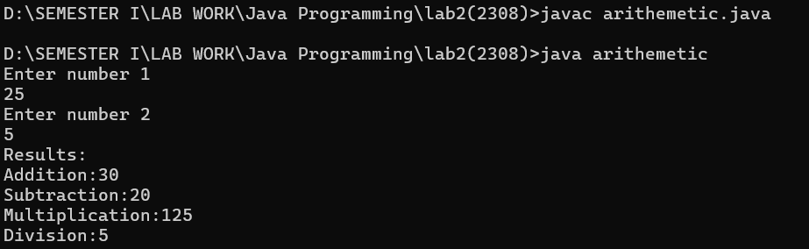

- Unary Operators

import java.util.*;
public class unary
{
public static void main(String[] args) {
int num;
Scanner sc=new Scanner(System.in);
System.out.println("Enter number 1");
num=sc.nextInt();

System.out.println("Results:");
System.out.println("Pre-Increment:"+ ++num);
System.out.println("Post-Increment:"+ num++);
System.out.println("Post-Decrement:"+ num-- );
System.out.println("Pre-Decrement:"+ --num);
}
}

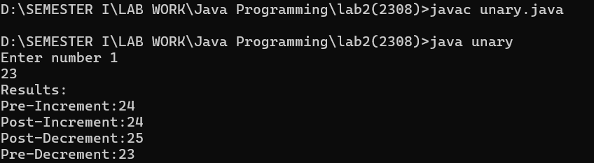

- Relational Operators

import java.util.*;
public class relational
{
public static void main(String[] args) {
int num1, num2;
Scanner sc=new Scanner(System.in);
System.out.println("Enter number 1");
num1=sc.nextInt();
System.out.println("Enter number 2");
num2=sc.nextInt();

System.out.println("Results:");
if(num1>num2){
System.out.println("Number 1 is greater than Number 2");}
else if(num2>num1){
System.out.println("Number 2 is greater than Number 1");}
else{
System.out.println("Number 1 and Number 2 are equal");}

}
}

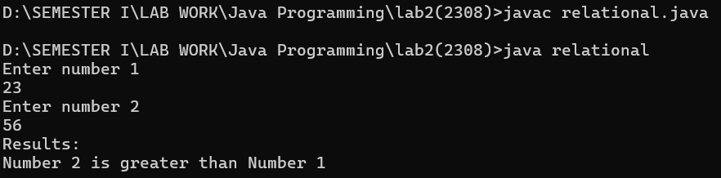

- Logical Operators

import java.util.*;
public class logical
{
public static void main(String[] args) {
int a, b;
Scanner sc=new Scanner(System.in);
System.out.println("Enter number 1");
a=sc.nextInt();
System.out.println("Enter number 2");
b=sc.nextInt();

boolean and= (a>0) && (b>0);
boolean or= (a>0) || (b>0);
boolean not=!(a>b);

System.out.println("Results:");
System.out.println("(a>0) && (b>0):"+ and);
System.out.println("(a>0) || (b>0):"+ or);
System.out.println("!(a>b):"+ not);

}
}

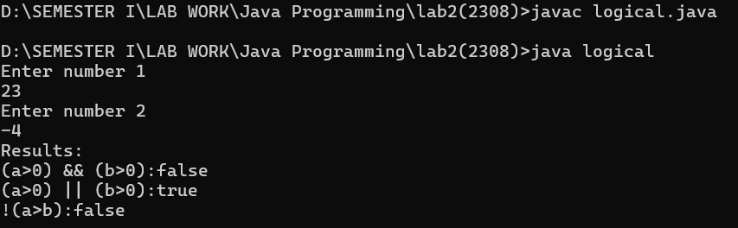

- Bitwise Operators
import java.util.*;
public class bitwise
{
public static void main(String[] args) {
int a, b;
Scanner sc=new Scanner(System.in);
System.out.println("Enter number 1");
a=sc.nextInt();
System.out.println("Enter number 2");
b=sc.nextInt();

int and= a&b;
int or= a|b;
int not= ~a;
int ls=a<<1;
int rs=a>>1;

System.out.println("Results:");
System.out.println("a&b:"+ and);
System.out.println("a|b:"+ or);
System.out.println("~a:"+ not);
System.out.println("a<<1:"+ ls);
System.out.println("a>>1:"+ rs);

}
}
